Project Design Phase-II Technology Stack (Architecture & Stack)
Date  Team ID  Project Name  Maximum Marks | 30 June 2025  LTVIP2025TMID49757  Visualization Tool for Electric Vehicle Charge and Range Analysis 4 Marks
Technical Architecture:
The Deliverable shall include the architectural diagram as below and the information as per the table1 & table 2
Example: Order processing during pandemics for offline mode

Reference: https://developer.ibm.com/patterns/ai-powered-backend-system-for-order-processing-during-
pandemics/
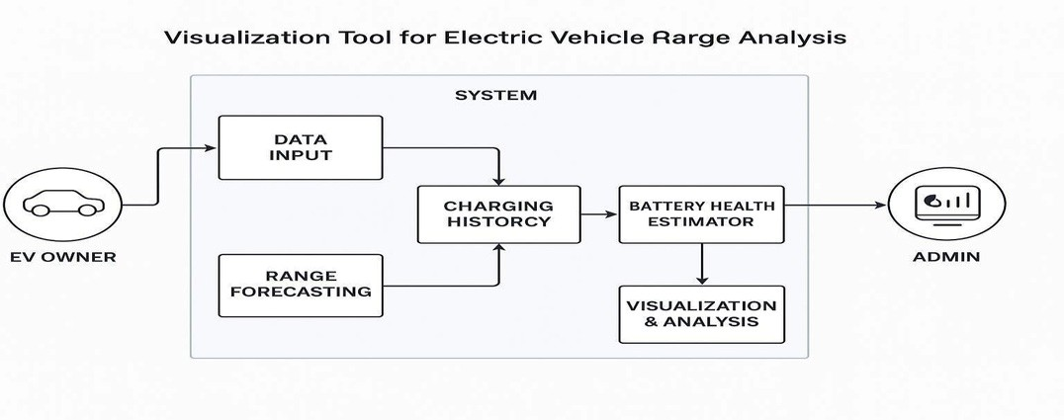
S.No | Characteristics | Description | Technology
1. | Performance | Rapid data response for range calculations, map updates, and analytics | Redis Cache, CDN, Async Processing
Table-1 : Components & Technologies:

2. Maintainability
S.No Component
- User Interface
- Authentication Module
- Vehicle Input System
- Range Estimation Engine
- Charging Station Mapper
- Charging History Module
- Recommendation System
- Admin Dashboard
- Database
- Hosting & Deployment
- API Integration Layer
Table-2: Application Characteristics:
Easy to update components like maps, APIs, or Modular Design, Git-based CI/CD. authentication without affecting the entire system.
Description Technology
Provides interactive views for EV Owners, Admins, HTML, CSS, JavaScript, React or
and Analysts Vue.js
Handles secure login, signup, and role-based Firebase Auth, OAuth 2.0, JWT access
Allows users to enter battery %, vehicle model, and JavaScript Form Logic, Python Flask
trip preferences AP
Calculates real-time range based on input and Python, Pandas, NumPy
terrain data
Displays nearby stations and highlights reachable zones.  Visualizes past charging sessions with analytics | Leaflet.js, Google Maps API Chart.js, D3.js, MongoDB.
Suggests ideal routes and charging stops | Machine Learning Model, Scikit-learn
Admin access to station management and user analytics  Stores user data, station info, vehicle profiles | React Admin, Node.js, MongoDB  MongoDB, Firebase Firestore
Runs backend and frontend on scalable infrastructure  Connects external services like Maps and EV data | Vercel, Netlify, AWS EC2 or Azure App Service.  REST APIs, GraphQL, Axios.
APIs

References:

Technology
Microservices, Docker, Kubernetes
S.No | Characteristics | Description
3.  4.  5. | Scalable Architecture  Availability  Reliability | Ensures the system handles increasing users, stations, and data; follows modular principles for flexibility  Stable performance across user scenarios with accurate real-time outputs  Design consideration for the performance of the application (number of requests per sec, use of Cache, use of CDN’s) etc.
Load Balancer (NGINX), Multi-region Hosting (Azure/AWS)
Automated Testing, Monitoring
(Prometheus, Grafana)

https://c4model.com/ https://developer.ibm.com/patterns/online-order-processing-system-duringpandemic/ https://www.ibm.com/cloud/architecture https://aws.amazon.com/architecture https://medium.com/the-internal-startup/how-to-draw-useful-technical-architecture-diagrams2d20c9fda90d

